**ENGINEERING JOURNAL TEMPLATE**

# Date

28th Oct – 1st Nov

# Tasks

* Research graphs and suitable libraries
* Connecting the sensor data to the graph

# Reflection

* Plans for Android studio taking up a lot more time than originally expected, but learning a lot
* Becoming very familiar with android studio.

# Issues:

*Hardware:*

Software only this week

*Software:*

1. Main app having problem running the Gradle, XML file not found. After googling, I have found it to be a common issue.
   1. Will try to clear cache as suggested
   2. Cache did not work, I feel like the gradle has become corrupted or outdated, will start a new project and copy the source files over
2. Download graph view library and begin examples

# Solutions

*Hardware:*

* Working on hardware this week

*Software:*

1. 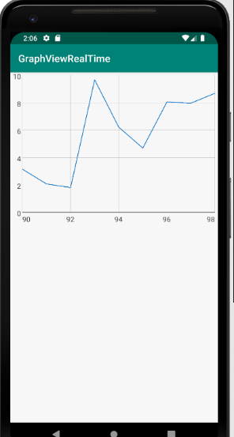Graphview library working well once I got the library installed correctly. Happy with real time input on these example graphs. Next step is to get data from the Pi displaying on the app.
2. Have looked into MQTT network protocol.